WSEI University in Lublin

Faculty of Transportation and Information

Virtualization techniques, containerization

Laboratory
Deployment of a Containerized App with Docker & Docker Compose

Name: Winston Huruva
Student ID: 43614

Introduction

This report documents the deployment of a containerized application using Docker and Docker Compose. It systematically traces each implementation phase, from project structure preparation through to building and testing both backend services and the Nginx web server. The accompanying screenshots demonstrate executed commands, configuration files, and launched containers, culminating in a fully functional multi-service environment.

Creating the project structure
This section demonstrates the establishment of the initial directory structure for organizing the containerized application. It includes the creation of dedicated directories for the backend service, Nginx configuration files, and Docker resources, providing a logical foundation for the subsequent deployment workflow.
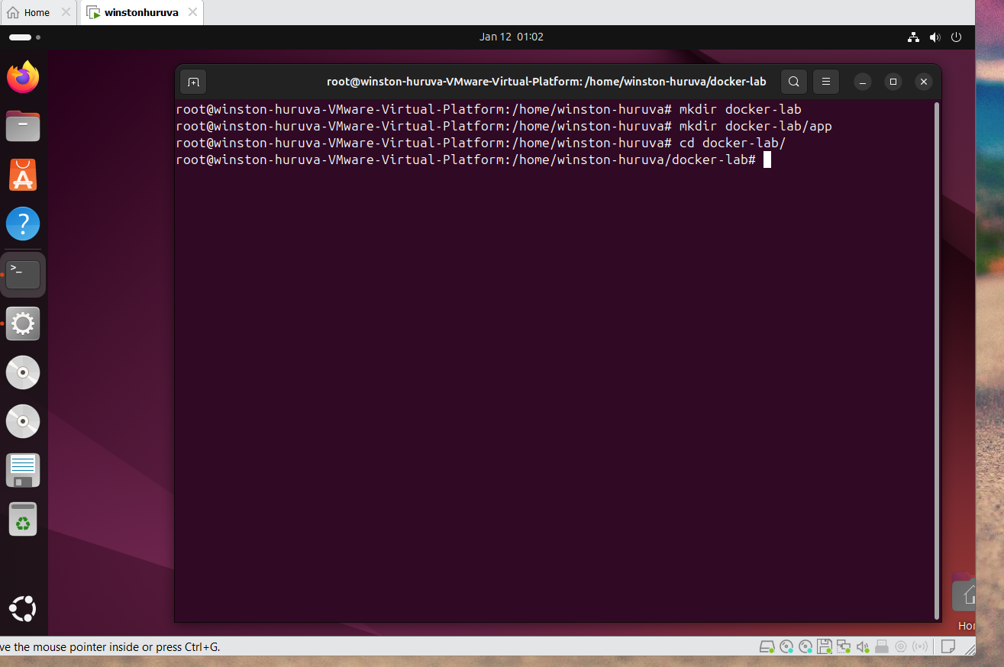

Creating Nginx configuration
This section demonstrates creation of the Nginx configuration file (nginx.conf), which defines routing rules and proxy directives. The configuration enables Nginx to forward incoming HTTP requests to the backend service, establishing the reverse proxy architecture essential for the multi-container application.
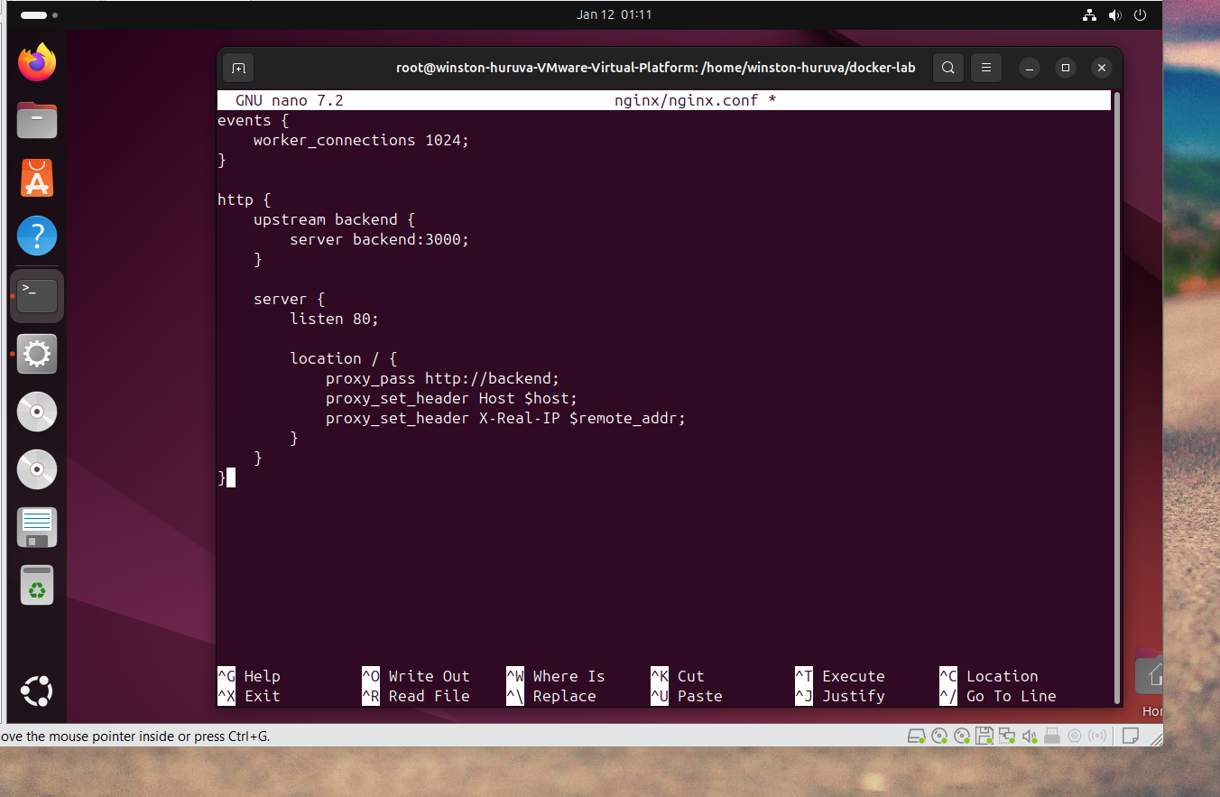

Creating the backend Dockerfile

This screenshot demonstrates creation of the backend service's Dockerfile using the nano text editor. The Dockerfile defines the containerization process: specifying a Node.js base image, setting the working directory, installing dependencies, copying application code, exposing port 3000, and configuring the startup command. This file serves as the blueprint for building the backend container image.

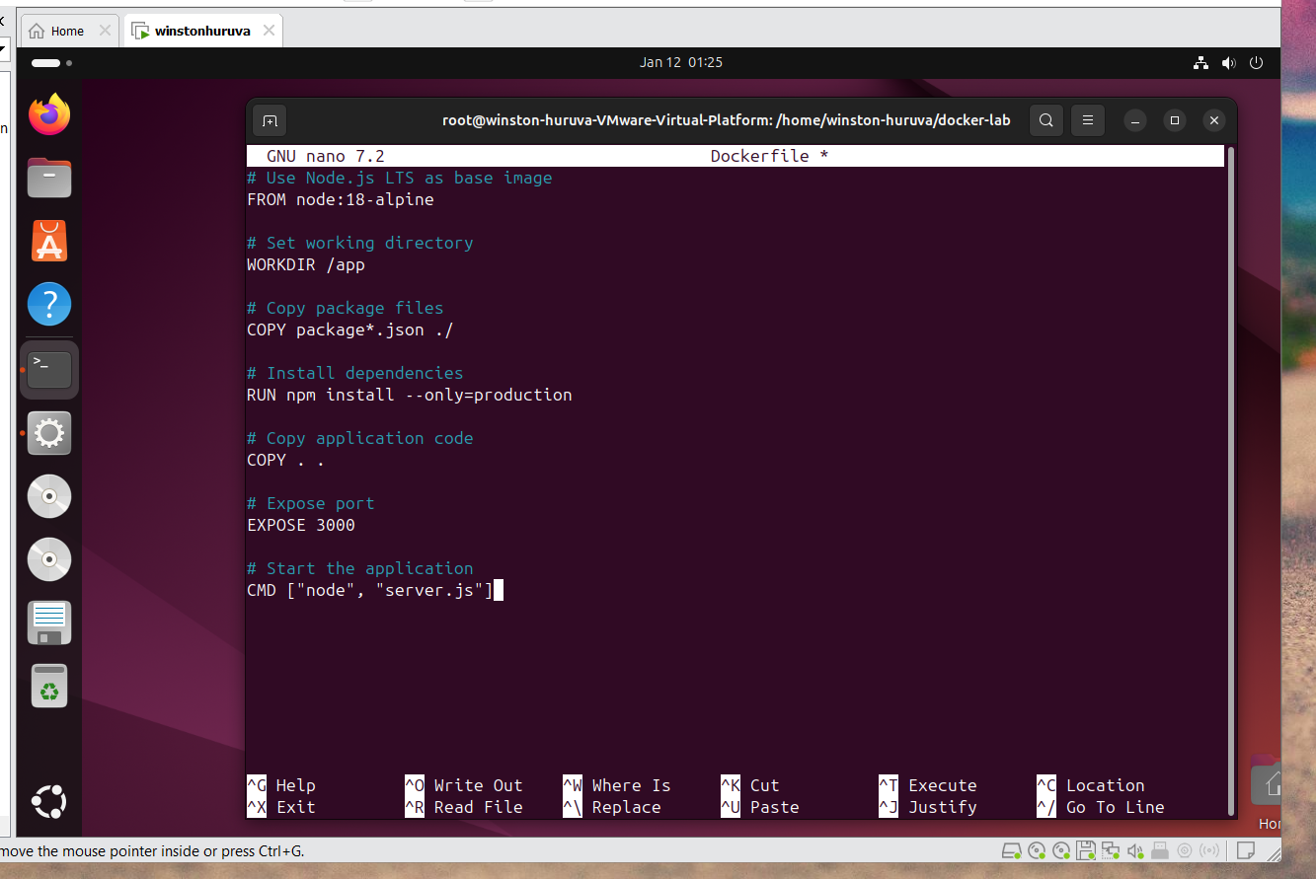

Create the Flask backend
This section demonstrates creation of the Flask backend application (app.py) which serves as the containerized backend service. The code defines RESTful endpoints for health checking and API responses, establishing the foundation for Nginx reverse proxy communication within the multi-service architecture.
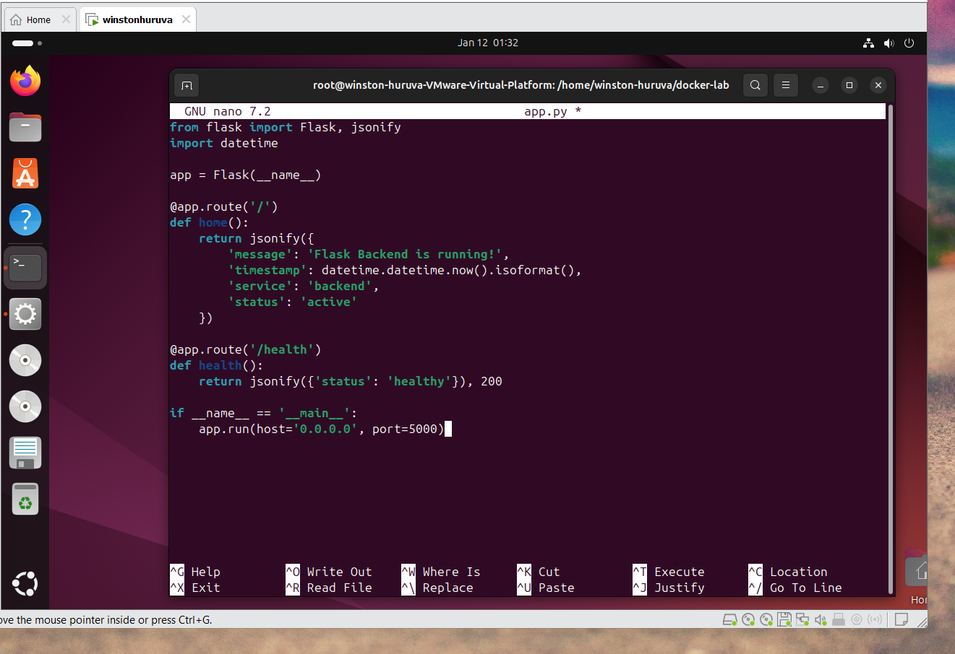

Create a custom Docker network
This screenshot demonstrates creation of a custom Docker bridge network using docker network create mynetwork. This dedicated network provides isolated communication between the backend and Nginx containers, enabling service discovery via container names while maintaining network segmentation from other Docker deployments.
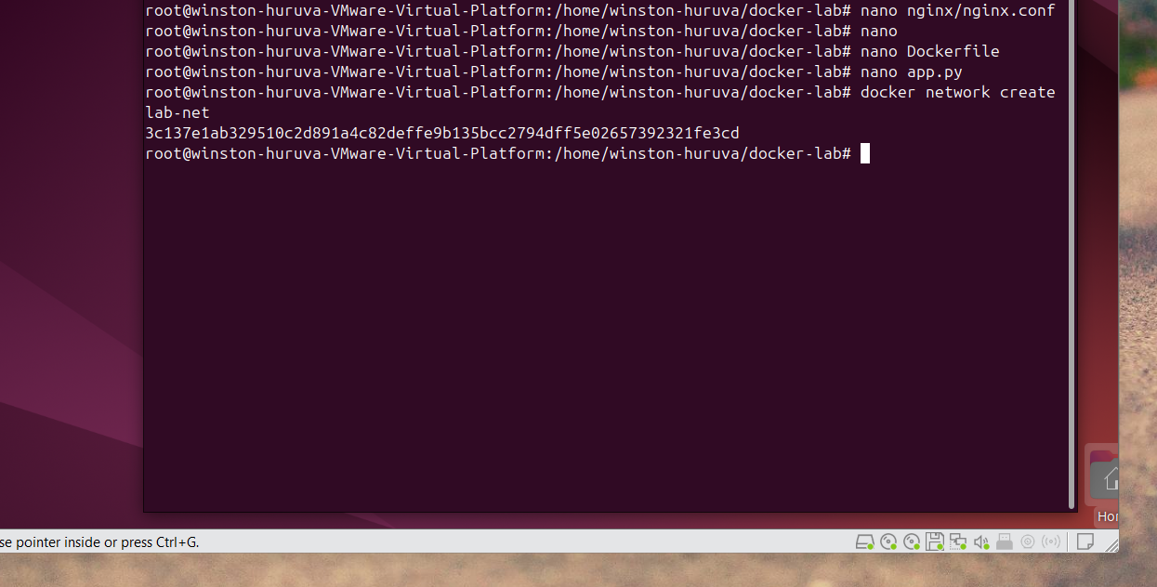

Build the backend container
This illustrates the process of building the backend Docker image. It includes Docker’s steps for assembling layers and installing dependencies in preparation for running the service.
